|  |  |  |  |  |  |  |  |  |  |  |  |  |  |  |  |  |
| --- | --- | --- | --- | --- | --- | --- | --- | --- | --- | --- | --- | --- | --- | --- | --- | --- |
| Software Requirements Specifications  Online Domestic Services  Project Code:  BS-313537  Internal Advisor:  Dr. Hafiz Faisal Shahzad  Project Manager:  Dr. Muhammad Ilyas  Project Team:   |  |  |  |  | | --- | --- | --- | --- | | **Sr. No** | **Name** | **Roll No** | **Role** | | 1. | Aleena Nadeem | BSEF19M037 | Team Leader | | 2. | Maria Zareef | BSEF19M031 | Team Member | | 3. | Aqib Ijaz | BSEF19M035 | Team Member |   Submission Date:  15-11-2022 _____________________ Project Manager’s Signature |

**Document Information**

| Category | Information |
| --- | --- |
| Customer | CS & IT, UOS |
| Project | Online Domestic Services |
| Document | Software Requirement Specifications |
| Document Version | 1.0 |
| Identifier | BS-313537 |
| Status | Draft |
| Author(s) | Aleena Nadeem  Maria Zareef  Aqib Ijaz |
| Approver(s) | Dr. Muhammad Ilyas |
| Issue Date | Oct 19, 2022 |
| Document Location | University of Sargodha |
| Distribution | 1. Advisor 2. PM 3. Project Office |

**Definition of Terms, Acronyms and Abbreviations**

| Term | Description |
| --- | --- |
| ODS | Online Domestic Services |
| SRS | Software Requirements Specifications |
| HTTP | Hypertext Transfer Protocol |
| CSS | Cascading Style Sheet |
| HTML | Hypertext Markup Language |
| SDLC | Software Development Life Cycle |
|  |  |
|  |  |

**Table of Contents**

1. Introduction 4

1.1 Purpose of Document 4

1.2 Project Overview 4

1.3 Scope 4

2. Overall System Description 5

2.1 User characteristics 5

2.2 Operating environment 5

2.3 System constraints 5

3. External Interface Requirements 6

3.1 Hardware Interfaces 7

3.2 Software Interfaces 7

3.3 Communications Interfaces 7

4. Functional Requirements 8

5. Non-functional Requirements 9

5.1 Performance Requirements 9

5.2 Safety Requirements 9

5.3 Security Requirements 9

5.4 User Documentation 9

6. Assumptions and Dependencies 10

7. System Architecture 11

8. Use Cases 12

8.1 Use Case Diagrams 13

8.2 Use Case Description 18

9. Graphical User Interfaces 19

10. High Level Design 26

10.1 ER Diagram 26

10.2 Data Dictionary 26

10.2.1 Data 1 27

10.2.2 Data 2 28

10.2.3 Data n 29

11. Requirements Traceability Matrix 30

12. Risk Analysis 31

13. Cost Estimation Sheet 31

14. References 32

# Introduction

We are developing a platform, which will facilitate the customer to provide information about domestic services. Our platform will provide an easy way to find trusted helpers. A customer can simply complain and send feedback after login.

* 1. Purpose of Document

This Software Requirements Specification provides a description of all functions, specifications, external behavior, design constraints and functional and non-functional requirements. It will provide a detailed description of the online home service system. The purpose of the document is to define the system, and its requirements with respect to customers and service provider, we shall predict how we hope this will provide a better understanding of the project and outline concepts of later development. The primary objective of this system is to provide home services at your fingertips with just a click. This document primarily written to understand the requirements of application how it will develop and how service providers and service seekers will communicate with each other.

* 1. Project Overview

We are developing a software that will provide all basic household services at your fingertips. This app will be innovative and interesting as you can get all the benefits like search, accuracy, appointment with service provider and send payment from a single app. We will design an interactive user interface for searching services on the go.

* This app will provide details about experience, performance and rating of different service providers such as gym trainer carpenters, plumbers, electricians, etc. which other applications are not providing.
* This application will allow users to register as a person requiring a service or a person providing a service.
* This application will allow payment through online payment mode or cash on delivery mode.
* Customer can give feedback for the service-provider.
  1. Scope

The scope of our project is to provide a safe and user-friendly environment for online service booking. The main aim of the project is to provide an easy-to-use application for customer. A two-way communication platform between the service provider and the service receiver can eliminate the exhausting efforts of finding a suitable service provider. A feedback-based rating system can improve the skills of any service provider and the service recipient can ultimately get better services. The overall system can be design for increasing its capacity in response to additional requests for which the application provides the corresponding service overseas. Furthermore, this application will extend only by adding up the required services and more payment systems.

# Overall System Description

We will develop the web-based and android application, which will provide a social platform to user on which customer can complain /send information about any online domestic service. It run on the web browsers like Google Chrome, Firefox, Microsoft edge etc. This project is operable on both PC and smart phones.

* 1. User characteristics

In our application, following users are involved:

1. Admin
2. Service Provider/Worker
3. Customer

**Admin:**

The admin module will handle the user login to the application and database in order to resolve any issues related to the database. Admin will assign access rights to a user, manipulate the data and will manage all the transactions. Administrator is the super-user of the system and has maximum privileges to access the system. In domestic service application, he can verify service provider/worker and customer, can manages all the categories of service, take the payment from the customer and can send notifications to the customer and service provider.

**Service Provider/worker:**

In this android or web application, service provider will first do registration and then log in. Workers can get proper training of how to deal with customers, improve their skills to perform better job and get legal protection because according to International Domestic Workers’ Federation, some domestic workers face multiple forms of violence: like security issues, threats intimidation, physical abuse, bullying, harassment or lack of privacy. After this process, the service provider can view the service, which is ordered by the user and send acknowledgement to the user in positive reply.

**Customer:**

This application will provide the facilities to the customer such as registration, display profile of service provider, advertisement, check worker past rating or experience, user select and request for service, different online payment methods and give feedback about worker performance etc. Customer directly send payment to the organization and worker get their wages monthly or yearly bases according to their contracts.

2.2 Operating environment

User can run this application or software on a Browser like Mozilla Firefox, Internet explorer, Google Chrome using Pc and smart phones. However, Internet connection is required for any operating system or open-source software. Operating system that will be used for application is windows, Android, MAC OS X and Linux.

2.3 System constraints

Here we have following constraints:

**2.3.1 Software constraints:**

* System is web or android based so it need internet connection to run.
* Development tools: Android Studio, Visual Studio Code.
* Web-browsing software: Google chrome, Mozilla Firefox, Internet explorer used to run the code or file for testing during the development.
* Google Chrome: is used for searching out the system on the web.

**2.3.2 Hardware constraints:**

Hardware constraint is that the device should be a laptop, desktop and smart phone.

* Operating System: Compatible with Windows and Android
* Memory (RAM): 2 GB minimum, 4 GB recommended
* Screen resolution: 1280x1024 or larger
* Processor: Intel Core i4 or later
* Application window size: 1024x680 or larger

**2.3.3 Cultural constraints:**

In today competitive world success of any organization, much depend on effectiveness of its advertisement practice. Agencies use various kinds of attractive advertising such as bold images, adventures, romantic language to lure the customer and capture the maximum share. Therefore, when we will advertise our services we will make sure to do it according to norms and cultural values of Pakistan. Another major cultural constraint is language, which cause an issue of misunderstanding of meaning between sender and receiver. In order to deal with this, we will use English language in our application.

**2.3.4 Legal constraints:**

Domestic service web or android application includes some legal constraints such as

* Terms of Use and Privacy policy requirements
* Anti-Spam Laws and Disclaimers.
* App store agreements for distribution of application.
* Security Requirements for the application content.
* Confidentiality agreements
* Intellectual property rights
* End-user License Agreement
* Government rules and regulation
* Copyright and Plagiarism Requirements
* Content Licensing and Attribution
  + 1. **Environmental constraints:**

Our android or web application is feasible on any environment. However, android app will be develop using android studio and users will be able to download or install it from play store.

**2.3.6 User constraints:**

This application will specially design for household users who want services including woman, man, older. Anybody having a smart phone or Pc with internet can access this application.

**2.3.7 off the shelf components:**

* Easy to use and install application
* Customers get services at affordable prices
* Continuous support will be provided

# External Interface Requirements

An internal software system’s interaction with external parties is depicted in a context diagram.

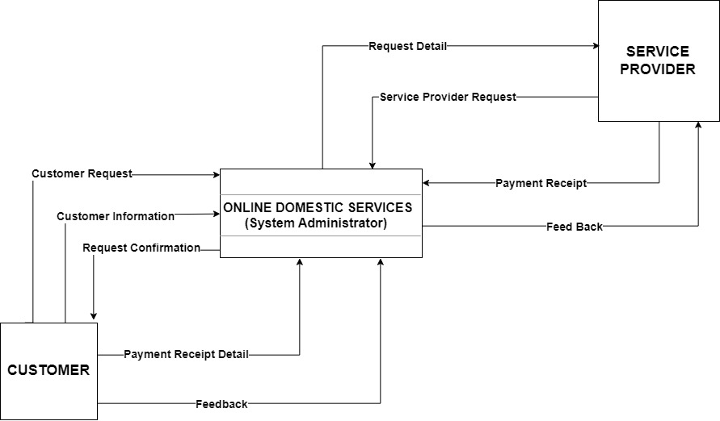

Fig 3.1 Context Diagram for External interfaces

* 1. Hardware Interfaces

Here we have some hardware specification or interface.

* 1.8 GHz processor
* 40GB of Hard disk
* Laptop
* Minimum 1GB RAM

3.2 Software Interfaces

* Operating system: Compatible with Windows and Android
* Web Browser: Internet Explorer, Google Chrome, Mozilla Firefox.
* Front End: Eclipse Versions
* Back End: SQL Server
* Development Languages for Web: PHP, JavaScript, Bootstrap, CSS, Html
* Development Languages for Android: Java
* Development tools: Android Studio, Visual Studio Code, Sublime Editor.
* XAMPP is a virtual server use to run the application on the web browser.

3.3 Communications Interfaces

* The system will use the HTTPS protocol for communication over the internet.
* After the users send the payment of service to organization, user can receive the confirmation message through registered email and mobile number.
* SSL certificates will used in application to secure online transactions and keep customer information private and secure.
* PHP that will use session variables to communicate between pages of website.

# Functional Requirements

Application has three basic modules; each module has its own set of characteristics. Module specific features helps to make app more useful. In these modules, we will have following pages and function/features that will help to understand the system.

* Login and Signup page is available in application.
* Services Category page for end users
* Service page that shows details about specific service.
* Add to cart page show selected services by customers.
* Service provider registration and profile page.
* Payment options for local and international users or customers.

**Customer Module:**

* We will provide the facilities to the customer such as registration or login on the application.
* The customer can check list of available domestic services on the home screen.
* The customer will be able to select and request for the available service.
* The customer will be able to pay for the services using several payment options like credit, debit card, easy paisa or jazz cash integration as well.
* After payment customer will receive an invoice through registered e-mail and/or contact numbers.
* The customer will be able to give ratings and reviews on the base of performance of service providers. This serves as input and lets other users pick service providers with higher ratings.

**Service Provider Module:**

* The service provider will be able to register and fill the required information about the category of service he is providing to user.
* After registration service provider will sign contract with organization through this system and organization will protect their legal rights.
* Service provider will get proper training from organization to improve their skills.
* Service provider can edit the details of his profile.
* The service provider can view the service ordered by user and will approve it.
* Service provider can update the details or information later.
* Customers will send payment to organization and service provider get their wages according to contract.
* Service Provider can view the feedback and ratings of customers via email or on dashboard.

**Admin panel:**

* The admin module will handle the users and service provider registration to the application
* Admin will manage database in order to resolve any issues.
* Admin will assign access rights to a user and service provider.
* Admin will manipulate data and has maximum privileges to access the system.
* Admin will manage all the categories of service in application.
* Admin will take the payment from the customer.
* Admin will send notification to the customer and service provider.
* Admin will manage all the transactions and payment details of user and service provider.

# Non-functional Requirements

System properties including security, reliability, performance, maintainability, scalability, and usability are defined by nonfunctional requirements (NFRs). They act as limitations or restrictions on how the system designed for the various backlogs. There will be the following non-functional requirements in the online insurance:

* Demands for app continuous functioning, such as 24/7, minimum idle time, etc., will make flexible service-based architecture highly desired.
* Better component design for improved peak performance.
* The capability to conduct online transactions and get data at any hour of the day or night.

* 1. Performance Requirements
* The system should be available to users 24 hours a day, 365 days a year.
* The system must be able to support 1500 users at a time.
* User private and confidential information should be protected.
* The system should be secure enough to carry out all the banking transactions and payment processes.
* Any interaction between user and app should not exceed 1 second.
* The system must be able to recover quickly after loss or in case of failure.

* 1. Safety Requirements

As the system is online, so the chance of data stealing increases. All transaction held online, connected with bank accounts of user, which is of main concern to provide secure platform where confidential information of user is safe from malicious attacks or in case of loss of data. Many websites frequently infected with malware and adware. Password leaks are the main cause of security attacks. Users to choose strong passwords and urge them to change their passwords frequently across accounts if you want to prevent the majority of attacks. App Vulnerabilities and Backdoors are the other main cause of data stealing and damage.

There few simple guidance that, if followed, can aid with data protection.

* No third-party stakeholders receive sensitive information
* No sensitive data in backups.
* Sensitive information is not kept other than the app's storage system.
* Users are informed of the risks and ways to prevent them through alert messages.
  1. Security Requirements
* The system must automatically log out all users after a certain amount of inactivity.
* All transactions involving personal customer information must be encrypted using SSL (secured socket layer), which is required by law.
* The system should not save any cookies revealing the user's password on the client's machine.
* Only authorized administrators will be able to access the system's back-end servers;
* Sensitive data will be encrypted before being delivered across unsecure networks, such as the internet.
  1. User Documentation

With our software, we will offer the following user documents:

* Instruction manual
* User Guide
* Software Documentation
* Training Manual

# Assumptions and Dependencies

It is assume that availability of financial budget and resources for project. The availability of required proper network and communication tools. The customer has a computer or a smart phone with the browser and have internet. The dependencies can be in the form of timely completion of project without any problem and the availability of Tools and Technology to complete the project in efficient manner.

# System Architecture

A formal description and representation of a system that supports the logic and behavior of the system is called an architecture description. The architectural layout of the system is shown in the figure, which includes the mobile application that connects to the server and the database via a mobile internet connection. A system architecture is a representation of a system in which there is a mapping of functionality onto hardware and software components, a mapping of the software architecture onto the hardware architecture, and human interaction with these components.

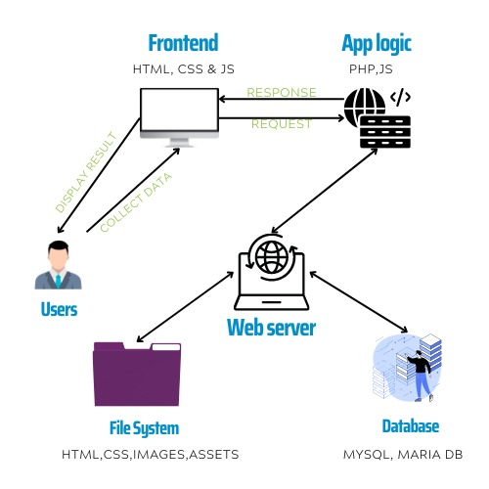

System Architecture

* 1. **Data Flow Diagrams**

A data flow diagram (DFD) models the process features of an information system by graphically depicting the "flow" of data through it. We can examine the operation of the user display model in this data flow diagram. Flow diagrams are typically created using straightforward symbols. It is a method of displaying the data flow of a system or a process.

**Data flow Diagram level 0**

Figure represents the customer and admin engages with the home service application, and in turn the applications store all the details in database.

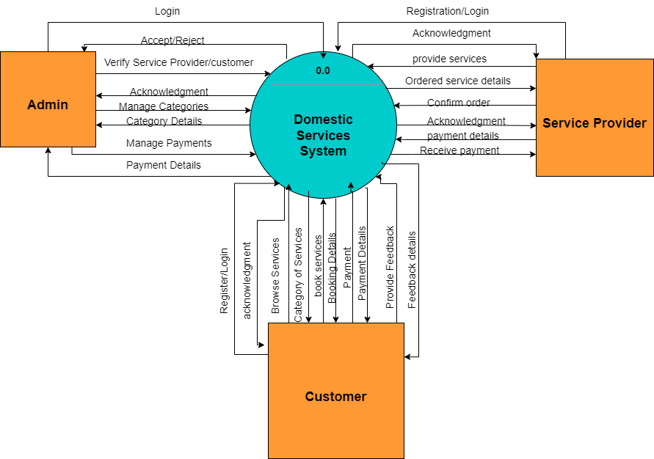

**Fig 7.1 Context Diagram for External interfaces**

**Data Flow diagram level 1:**

In 1-level DFD, a context diagram is composed of process. In this, we highlight the main functions of the system and breakdown the high-level process of 0-level DFD into the process. Figure represents the client action starting from login or registering to the application, selection of the service to the knowing the work status and making payment for the service availed and providing feedback to the service. This diagram shows all the processes that comprise a single process on the level 1 diagram and how information moves from and to each of these processes.

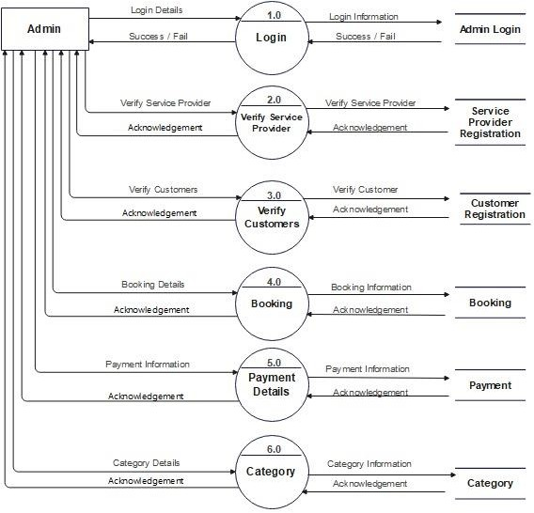

**Fig 7.2.1 Admin DFD Level 1 Diagram**

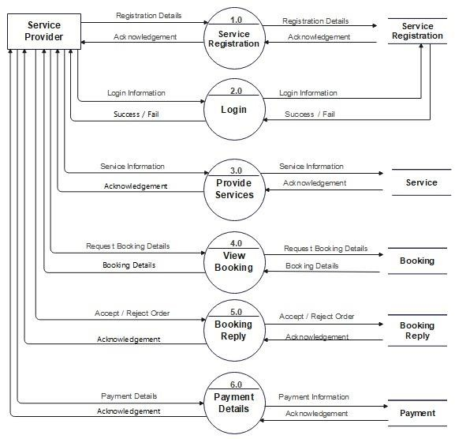

**7.2.2: Service Provider DFD Level 1 Diagram**

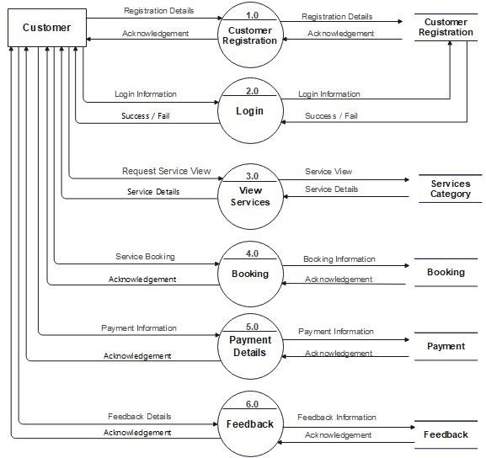

**7.2.3: Customer DFD Level 1 Diagram**

# Use Cases

* 1. Use Case Diagrams

A set of use cases, actors, and their relationships are shown in use case diagrams. They represent a system's use case perspective. A use case represents a certain system functionality. In this section provide use case diagrams using UML convention.

* + 1. **Customer Use Case Diagram:**

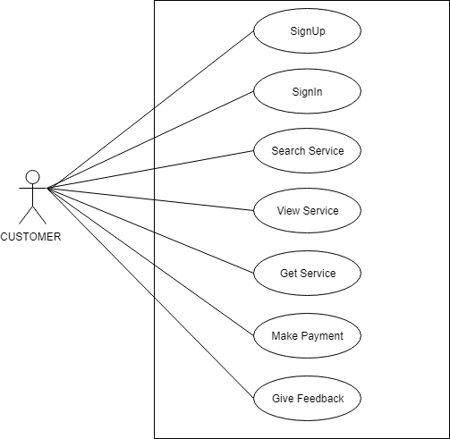

* + 1. **Admin Use Case Diagram:**

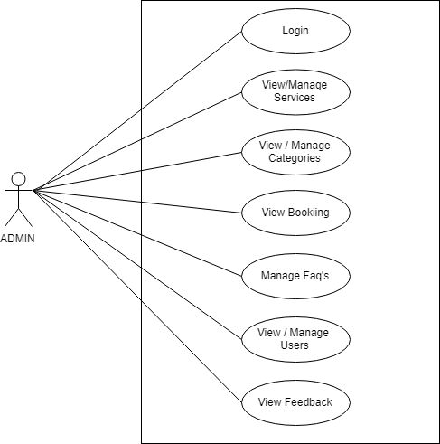

* + 1. **Service Provider Use Case Diagram:**

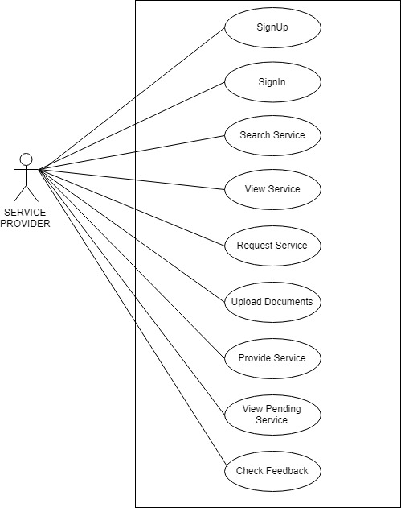

* + 1. **Whole system Use Case Diagram:**

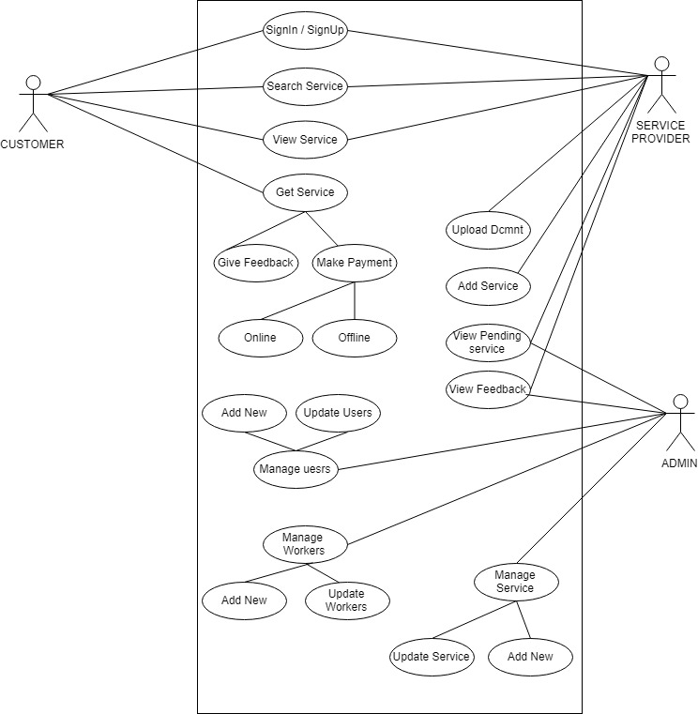

* 1. Use Case Description

Each Use Case has a description, which describes the functionality that will be built in the proposed system. The Use Case description for home services app is given below:

|  |  |  |  |  |
| --- | --- | --- | --- | --- |
| **8.1.1: Login** | | | | |
| **Actors:**  Admin, customer, Service provider | | | | |
| **Feature:** This USECASE allows the service provider, customer and admin to login using valid Login Id and Password | | | | |
| **Use case Id:** | | 8.1.1 | | |
| **Pre-condition:** | | The Service provider, user and admin must be Logged onto System in order to being the use case | | |
| **Scenarios**   1. User or service provider or admin enters the login ID and Password. 2. System checks login Id and password if person is a user or helper or admin. 3. User register on the website or app, to search for helper availability, to enter the request, to check the status of request any time. 4. Customer registers on website and search for services. 5. Admin helps to allocate a Helper to the request. | | | | |
| **Step#** | **Action** | | | **Software Reaction** |
| **1.** | Enters Login ID and Password | | | System checks login id and password |
| **2.** | Member Register on the website | | | System Shows the Member’s profile |
|  |  | | |  |
| **Alternate Scenarios:** | | | | |
| **1a: Invalid user id/password:**  if the user id or password is invalid, system generates an error message  **2a: Database connection failure:** S**y**stem prompts the user and get back to home page | | | | |
| **Post Conditions** | | | | |
| **Step#** | **Description** | | | |
| **1** | If the use case is successful, the system allows the user to register and search. If not, the system generates an error message. | | | |
|  |  | | | |
|  |  | | | |
| **Use Case Cross reference** | | | <Registration> | |
| **User Interface reference** | | | * Searching Interface * Contact us interface | |

|  |  |  |  |  |
| --- | --- | --- | --- | --- |
| **8.1.1: Home screen** | | | | |
| Actors: User | | | | |
| Feature: This will allow the user to see the features of the website and the main pages of the website. | | | | |
| **Use case Id:** | | 8.1.1 | | |
| **Pre-condition:** | | The user had signed up/ login. | | |
| **Scenarios** | | | | |
| **Step#** | **Action** | | | **Software Reaction** |
| **1.** | A user must have login/signup in the application | | | Homepage appears |
| **2.** | The first screen shows a list of pages available in an app | | | The screen shows different pages options |
| **3.** | A user can select any of them and request employees that are registered in an app. | | |  |
| **4.** | Once a user selects, any services request page will appear. | | | The selected services option page appears |
| **Post Conditions** | | | | |
| **Step#** | **Description** | | | |
| **3.** | Different services are listed user selects their required service then the particular screen will appear. | | | |
| **Use Case Cross referenced** | | | Login | |
| **Use Case Cross referenced** | | | Browse Categories | |

|  |  |  |
| --- | --- | --- |
| **8.1.1: Search Service** | | |
| **Actors:**  User | | |
| **Feature:** Browse the available services | | |
| 8.1.1 | | |
| User had sign up/login, selected the services and had done form filling | | |
| **Scenarios** | | |
| **Action** | | **Software Reaction** |
| User will browse the available services. | | Software will then add the selected product into the cart |
| **Post Conditions** | | |
| **Description** | | |
| If successful, the system allows the user to search all the available services. If not, the system generates an error message.  User should select the service which he wants to purchase | | |
| **Use Case Cross referenced** | Browse Categories | |

|  |  |  |  |  |
| --- | --- | --- | --- | --- |
| **8.1.1: Get Service** | | | | |
| **Actors:**  User | | | | |
| **Feature:** Add the Service into the cart | | | | |
| **Use case Id:** | | 8.1.1 | | |
| **Pre-condition:** | | User had sign up/login, selected the services and had done form filling | | |
| **Scenarios** | | | | |
| **Step#** | **Action** | | | **Software Reaction** |
| **1.** | User will Input the details | | | Software will then add the selected Services into the cart |
| **Post Conditions** | | | | |
| **Step#** | **Description** | | | |
| **1.** | User should add the Services which he/she wants to buy into the cart | | | |
| **Use Case Cross referenced** | | | Add to Cart | |

|  |  |  |  |  |
| --- | --- | --- | --- | --- |
| **8.1.1: Make Payment** | | | | |
| **Actors:**  User | | | | |
| **Feature:** Add the home address and payment details | | | | |
| **Use case Id:** | | 8.1.1 | | |
| **Pre-condition:** | | User had sign up/login, selected the services and browsed all the categories available and selected the desired service | | |
| **Scenarios** | | | | |
| **Step#** | **Action** | | | **Software Reaction** |
| **1.** | User will Input the details like credit card information and address details | | | Software will then update and show the final receipt and details of customer profile |
| **Post Conditions** | | | | |
| **Step#** | **Description** | | | |
| **1.**  **2.** | User should confirm the services which he/she want to purchase  User can also update the profile | | | |
| **Use Case Cross referenced** | | | Confirm payment | |

|  |  |  |  |  |
| --- | --- | --- | --- | --- |
| **8.1.1: Get Feedback** | | | | |
| **Actors:**  User | | | | |
| **Feature:** provide feedback and ratings | | | | |
| **Use case Id:** | | 8.1.1 | | |
| **Pre-condition:** | | User had sign up/login, selected the services and has purchased a service. | | |
| **Scenarios** | | | | |
| **Step#** | **Action** | | | **Software Reaction** |
| **1.** | User will give ratings and feedback about the services | | | Software will display the ratings and services reviews on home screen |
| **Post Conditions** | | | | |
| **Step#** | **Description** | | | |
| **1.**  **2.** | User should submit the review or ratings and can view it on profile.  Comments are saved in the database and shown on the screen. | | | |
| **Use Case Cross referenced** | | | Ratings | |

|  |  |  |  |
| --- | --- | --- | --- |
| **8.1.2: Admin Login** | | | |
| **Actors:**  Admin | | | |
| **Feature:** This screen allows the user to sign up in-app | | | |
| **Use case Id:** | | 8.1.2 | |
| **Pre-condition:** | | Admin has an access to website. | |
| **Scenarios** | | | |
| **Step#** | **Action** | | **Software Reaction** |
| **1.** | The admin inserts a name, email id, and password | | Software saves that detail in database. |
| **2.** | Admin clicks on register button and waits for next step. | | Software then registers that admin and ask for login. |
| **3.** | If already had an account, then login. | | Software then takes user to home screen. |
| **Post Conditions** | | | |
| **Step#** | **Description** | | |
| **2.** | Admin clicks on the register button, which made “NEW_USER_REGISTERATION” or “EXISTING_USER_REGISTRATION” doing all the text on the current screen and transfers it to app server using services. | | |

|  |  |  |  |
| --- | --- | --- | --- |
| **8.1.2: Mange/View Services** | | | |
| **Actors:**  Admin | | | |
| **Feature:** This screen allows the user to update and keep record of services | | | |
| **Use case Id:** | | 8.1.2 | |
| **Pre-condition:** | | Admin has an access to website. | |
| **Scenarios** | | | |
| **Step#** | **Action** | | **Software Reaction** |
| **1.** | The admin can view and approve new services | | Software saves those details in database. |
| **2.** | Admin can update services information | | Software then displays the updated information |
|  |  | |  |
| **Post Conditions** | | | |
| **Step#** | **Description** | | |
| **2.** | Admin clicks on the Mange Service button | | |

|  |  |  |  |
| --- | --- | --- | --- |
| **8.1.2: Mange/View Bookings** | | | |
| **Actors:**  Admin | | | |
| **Feature:** This screen allows the user to view and keep record of bookings details | | | |
| **Use case Id:** | | 8.1.2 | |
| **Pre-condition:** | | Admin has an access to website. | |
| **Scenarios** | | | |
| **Step#** | **Action** | | **Software Reaction** |
| **1.** | The admin can view Bookings details | | Software shows those details |
| **2.** | Admin will be able update and delete the records | | Software then displays the updated information |
|  |  | |  |
| **Post Conditions** | | | |
| **Step#** | **Description** | | |
| **2.** | Admin clicks on the Mange Booking button | | |

|  |  |  |  |
| --- | --- | --- | --- |
| **8.1.2: Mange/View Users** | | | |
| **Actors:**  Admin | | | |
| **Feature:** This screen allows the user to view and keep record of User details | | | |
| **Use case Id:** | | 8.1.2 | |
| **Pre-condition:** | | Admin has an access to website. | |
| **Scenarios** | | | |
| **Step#** | **Action** | | **Software Reaction** |
| **1.** | The admin can view User details | | Software shows those details |
| **2.** | Admin will be able update and delete the records | | Software then displays the updated information |
|  |  | |  |
| **Post Conditions** | | | |
| **Step#** | **Description** | | |
| **2.** | Admin clicks on the Mange User button | | |

|  |  |  |  |
| --- | --- | --- | --- |
| **8.1.2: Mange/View Feedback** | | | |
| **Actors:**  Admin | | | |
| **Feature:** This screen allows the user to view and keep record of Feedback | | | |
| **Use case Id:** | | 8.1.2 | |
| **Pre-condition:** | | Admin has an access to website. | |
| **Scenarios** | | | |
| **Step#** | **Action** | | **Software Reaction** |
| **1.** | The admin can view and mange Feedback details | | Software shows those details and save the data in database |
| **2.** | Admin will be able to update the records | | Software then displays the updated information |
|  |  | |  |
| **Post Conditions** | | | |
| **Step#** | **Description** | | |
| **2.** | Admin clicks on the Mange Feedback button | | |

# Graphical User Interfaces

Some of the graphic user interfaces completed are:

**9.1 Home Screen**

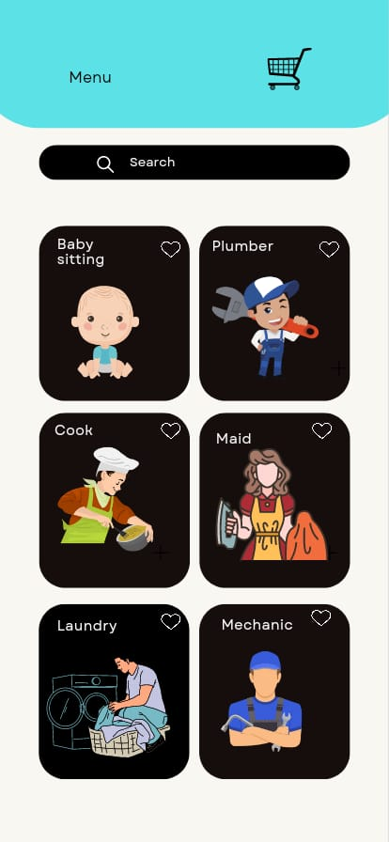

**9.2 Registration:**

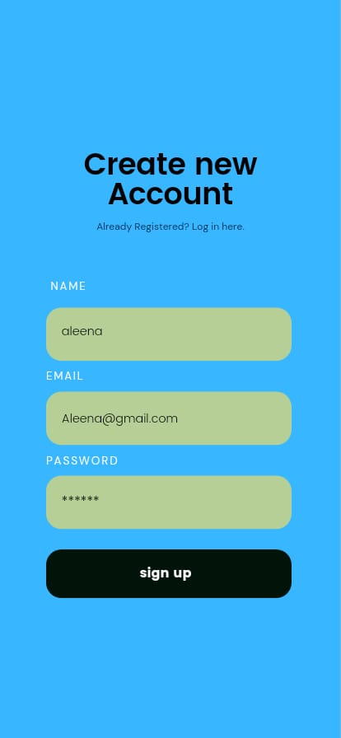

**9.3 User Profile:**

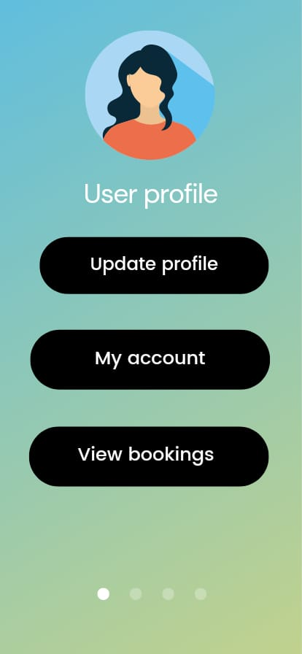

**9.4 Give Feedback:**

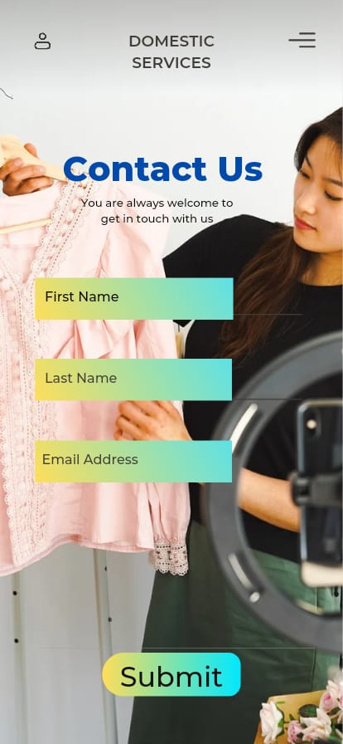

**9.5 Home Page of web application**

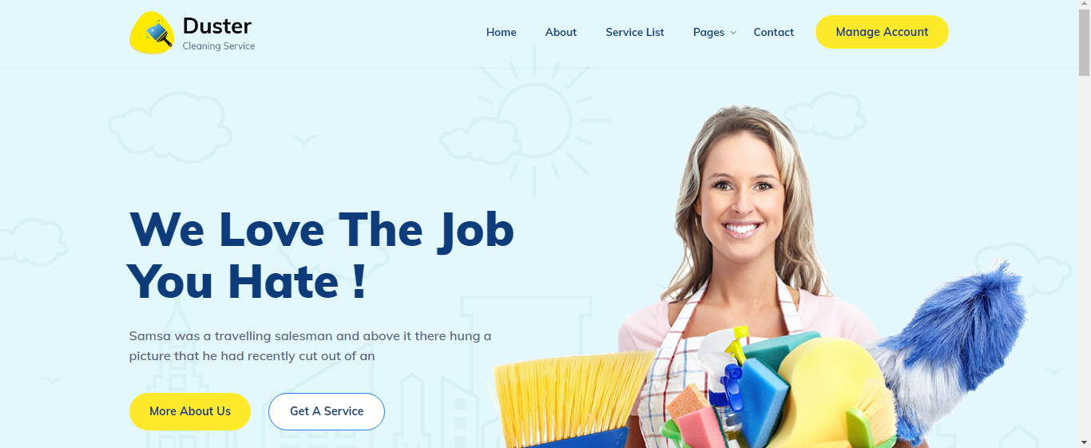

**9.6 About Us**

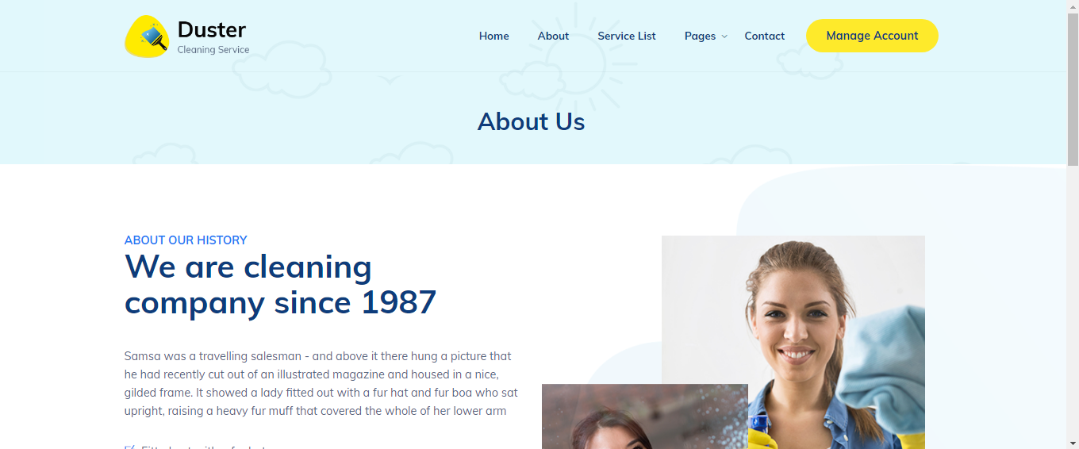

**9.7 Contact Us**

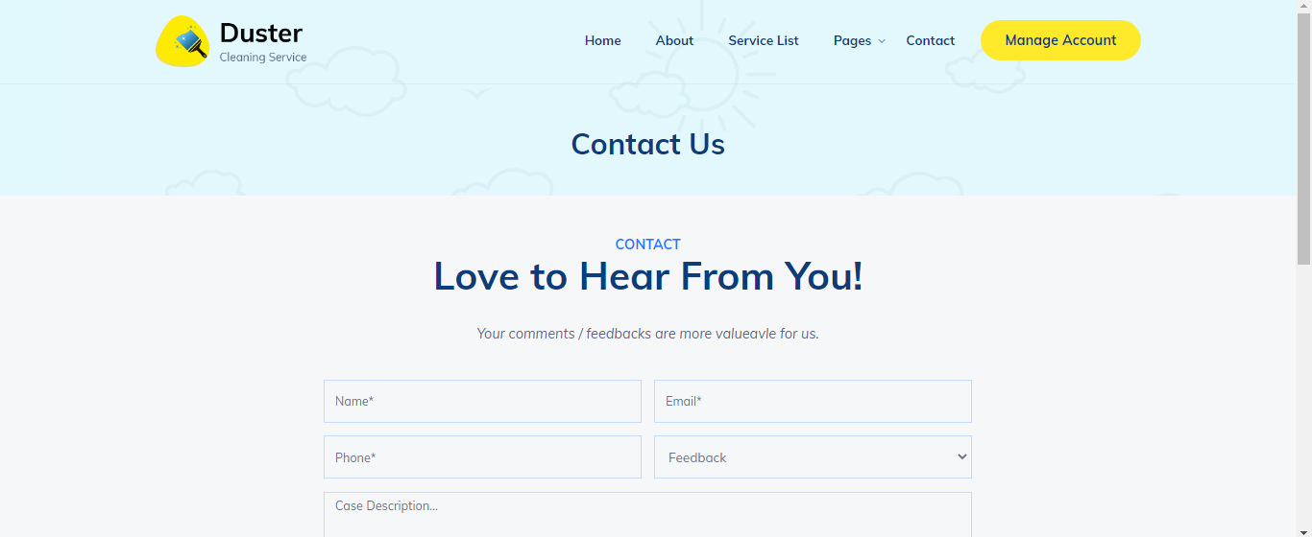

# 9.8 Our Services

# Screenshot (116)

|  |  |  |
| --- | --- | --- |
| **9.1: Login** | | |
| **Interface Id.** | | 9.1 |
| **Use case Reference** | | 8.1.1 |
| **Snapshot** | | |
|  | | |
| **Data dictionary reference** | | |
| **Label** | **Data dictionary identifier** | |
|  | Refer to fields in data dictionary | |
|  |  | |
|  |  | |

|  |  |  |
| --- | --- | --- |
| **9.1 Home Screen** | | |
| **Interface Id.** | | 9.2 |
| **Use case Reference** | | 8.1.1 |
| **Snapshot** | | |
|  | | |
| **Data dictionary reference** | | |
| **Label** | **Data dictionary identifier** | |
|  | Refer to fields in data dictionary | |
|  |  | |

|  |  |  |
| --- | --- | --- |
| **9.3: Feedback/contact us** | | |
| **Interface Id.** | | 9.3 |
| **Use case Reference** | | 8.1.1 |
| **Snapshot** | | |
|  | | |
| **Data dictionary reference** | | |
| **Label** | **Data dictionary identifier** | |
|  | Refer to fields in data dictionary | |
|  |  | |

# High Level Design

* 1. ER Diagram

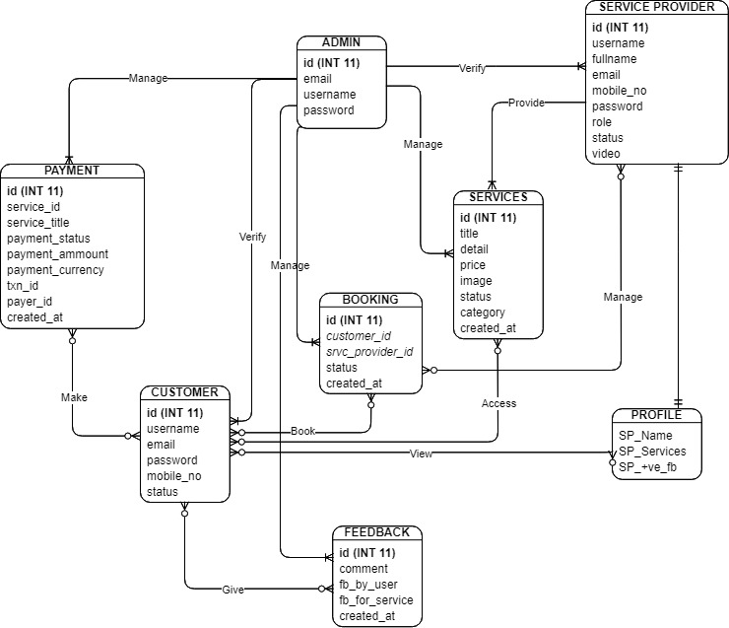

**Fig 10.1 Entity Relationship Diagram**

* 1. Data Dictionary

The convention recommended for writing the data dictionary is as follows.

10.2.1 Customers

|  |  |  |  |  |
| --- | --- | --- | --- | --- |
| **Field Name** | **Type** | **Length** | **Key Constraints** | **Description** |
| **Id** | INT | 10 | PRIMARY KEY |  |
| **Name** | STRING | 50 | NOT NULL | The name of the user |
| **Email** | VARCHAR | 100 | NOT NULL | Email of the user |
| **Password** | VARCHAR | 100 | NOT NULL | User’s Password must contain 8 letters with special characters |
| **Phone no.** | INT | 100 | NOT NULL | User’s Contact Number |
| **Forget_Token** | VARCHAR | 50 | NULL |  |
| **Cust_Status** | VARCHAR | 50 | NOT NULL | Active |
| **Cust_role** | VARCHAR | 50 | NOT NULL | User |
| **Created_at** | VARCHAR | 50 | NOT NULL | 9/11/2022 |

10.2.2 Categories

|  |  |  |  |  |
| --- | --- | --- | --- | --- |
| **Field Name** | **Type** | **Length** | **Key Constraints** | **Description** |
| **Cat_Id** | INT | 10 | PRIMARY KEY |  |
| **Cat_name** | STRING | 50 | NOT NULL | The name of the Category |
| **Cat_Status** | VARCHAR | 50 | NOT NULL | Active |
| **Cat_Icon** | VARCHAR | 50 | NOT NULL | Img |
| **Created_at** | VARCHAR | 50 | NOT NULL | 9/11/2022 |

10.2.3 Contact

|  |  |  |  |  |
| --- | --- | --- | --- | --- |
| **Field Name** | **Type** | **Length** | **Key Constraints** | **Description** |
| **C_Id** | INT | 10 | PRIMARY KEY |  |
| **C_Name** | STRING | 50 | NOT NULL | The name of the user |
| **C_Email** | VARCHAR | 100 | NOT NULL | Email of the user |
| **C_Phone** | VARCHAR | 100 | NOT NULL | User’s Contact Number |
| **C_feedback** | INT | 100 | NOT NULL | User feedback |

10.2.4 Payment

|  |  |  |  |  |
| --- | --- | --- | --- | --- |
| **Field Name** | **Type** | **Length** | **Key Constraints** | **Description** |
| **Id** | INT | 10 | PRIMARY KEY |  |
| **Item_Name** | STRING | 50 | NOT NULL | The name of the service that use select |
| **Item_Number** | VARCHAR | 100 | NOT NULL | Service no. |
| **Payment_amount** | Double | 100 | NOT NULL | Total services charges. |
| **Payment_status** | VARCHAR | 100 | NOT NULL | Show payment status(paid or not) |
| **Payment_method** | VARCHAR | 100 | NOT NULL | Different payment choices |
| **Item_Id** | VARCHAR | 100 | NOT NULL | Service id |
| **Payer_Id** | VARCHAR | 100 | NOT NULL | Customer id |
| **Trans_Id** | VARCHAR | 100 | NOT NULL | Transaction id |
| **Created_at** | VARCHAR | 100 | NOT NULL | 9/11/2022 |

10.2.5 Services

|  |  |  |  |  |
| --- | --- | --- | --- | --- |
| **Field Name** | **Type** | **Length** | **Key Constraints** | **Description** |
| **Service_Id** | INT | 10 | PRIMARY KEY |  |
| **Service_title** | MEDIUMTEXT |  | NOT NULL | The name of the service |
| **Service_overview** | LONGTEXT |  | NOT NULL | Service description |
| **Service_package** | MEDIUMTEXT |  | NOT NULL | Affordable packages. |
| **Service_price** | VARCHAR | 50 | NOT NULL | Service charges |
| **Service_photo** | VARCHAR | 50 | NOT NULL | Service photo |
| **Service_category** | VARCHAR | 50 | NOT NULL | Service category |
| **Service_status** | VARCHAR | 50 | NOT NULL | Service status (active or not) |
| **Created_at** | VARCHAR | 50 | NOT NULL | 9/11/2022 |

10.2.6 FAQ (Frequently asked question)

|  |  |  |  |  |
| --- | --- | --- | --- | --- |
| **Field Name** | **Type** | **Length** | **Key Constraints** | **Description** |
| **Faq_Id** | INT | 10 | PRIMARY KEY |  |
| **Faq_question** | MEDIUMTEXT |  | NOT NULL | Customers Questions |
| **Faq_answer** | MEDIUMTEXT |  | NOT NULL | Answer |
| **Faq_Status** | VARCHAR | 50 | NOT NULL | Active |
| **Created_at** | VARCHAR | 50 | NOT NULL | 9/11/2022 |

10.2.7 SMTP

|  |  |  |  |  |
| --- | --- | --- | --- | --- |
| **Field Name** | **Type** | **Length** | **Key Constraints** | **Description** |
| **Id** | INT | 10 | PRIMARY KEY |  |
| **Smtp_host** | STRING | 50 | NOT NULL | The name of the host |
| **Smtp_username** | VARCHAR | 100 | NOT NULL | Email of the registered user |
| **Smtp_password** | VARCHAR | 100 | NOT NULL | Password |
| **Smtp_port** | INT | 100 | NOT NULL | Port number |
| **Smtp_secure** | VARCHAR | 50 | NULL | SSL |
| **smtp_Status** | VARCHAR | 50 | NOT NULL | Active |

10.2.8 Service Provider

|  |  |  |  |  |
| --- | --- | --- | --- | --- |
| **Field Name** | **Type** | **Length** | **Key Constraints** | **Description** |
| **Id** | INT | 10 | PRIMARY KEY |  |
| **Name** | STRING | 50 | NOT NULL | The name of the service provider |
| **Email** | VARCHAR | 100 | NOT NULL | Email of the service provider |
| **Password** | VARCHAR | 100 | NOT NULL | Service provider password must contains 8 letters with special characters |
| **Phone no.** | INT | 100 | NOT NULL | Service provider Contact Number |
| **Forget_Token** | VARCHAR | 50 | NULL |  |
| **Photo** | VARCHAR | 50 | NOT NULL | Img |
| **Gender** | VARCHAR | 50 | NOT NULL | service provider gender |
| **Services** | VARCHAR | 50 | NOT NULL | Services that they will provide |

# Requirements Traceability Matrix

|  |  |  |  |  |  |  |
| --- | --- | --- | --- | --- | --- | --- |
| **Sr. #** | **Feature** | **Use case ID** | **UI ID** | **Priority** | **Build Number** | **Use Case Cross reference**  **(Related Use Cases)** |
| 1. | Create account | 8.1.1 |  | 1 | 8.1.1 |  |
| 2. | Login | 8.1.1 |  | 2 | 8.1.2 | Customer |
| 3. | Search service | 8.1.1 |  | 7 | 8.1.3 | Customer |
| 4. | Add service to cart | 8.1.1 |  | 6 | 8.1.4 | Customer |
| 5. | Payments | 8.1.1 |  | 3 | 8.1.5 | Customer |
| 6. | Manage bookings | 8.1.2 |  | 5 | 8.1.6 | Admin |
| 7. | Upload documents | 8.1.3 |  | 4 |  | Service Provider |
| 8. | Admin login | 8.1.2 |  | 8 |  | Admin |

# Risk Analysis

Every Web application has some unavoidable risks; where there is a use of the internet by the users; there are attackers to intrude on the confidentiality of users or disturb the service of the web app. Some of these risks are common and some are rare, but in fact, they are undeniable.

**Risk Identification:**

* The tools and technologies may replace by other new technologies.
* In future if we need to add new features and updates in app, for this purpose we hire new professionals for this project, the cost of project may increase then the budget of project.
* When the project could not be completed on a given time schedule, this could be a risk.
* If the user not update the app after some time, there is a risk of app to malfunction.
* If the requirements of user are changing frequently then there is a risk to project to get delayed
* Poor infrastructure of application could be a risk
* If the stakeholders are not collaborating and conducting meetings then there is a risk of project to collapse

**Risk Drivers:**

* Change in tools and technologies
* Running out of resources
* Frequently changing requirements
* Poor infrastructure
* Running out of time
* Running out of budget

**Percentage Impact of Risk Drivers:**

**Risk Mitigation Plan:**

* Make sure that all the stakeholders collaborate and attend meetings
* Listing all the high-level requirements in contract
* Monitor any updates on browser and make sure that our system UI and infrastructure works well on updated browser
* Make sure to update stakeholders with time and budget estimations to keep project on track.

# Cost Estimation Sheet

|  |  |  |
| --- | --- | --- |
|  | **Software development cost** | 6,00,000 rupees only |
|  | **Packaged software** | 30,000 rupees only |
|  | **Hardware** | 1,50,000 rupees only |
|  | **Network** | 54,000 rupees only |
|  | **Client** | 80,000 rupees only |
|  | **Misc.** | 1,30,000 rupees only |
|  |  |  |
|  |  | **Total cost = 10,44,000 rupees only** |

1. **Reference**
2. Jakarata. (2021). Legal protection needed to protect Domectic Workers. Retrieved from International labour organization.
3. Juddi, M. F., Perbawasari, S., & Zubair, F. (2021). The Communication Flow in the Protection of Indonesian Female Migrant Workers through the Migrant Worker Family Community (KKBM). *Journal of International Women's Studies*, *22*(5), 19-37.
4. Ahmand, W. (2018). Maid services. Retrieved from Maid in Pakistan: https://www.maidinpakistan.com.pk

4. Nykanen, E. (2015). home service concept . Retrieved from Research Gate: https://www.researchgate.net

5.Asrar, S. (2021). 'Are we not human?'Pakistan Domestic workers confront abuse. Retrieved from CsMonitor: https://www.csmonitor.com/World/Asia-South-Central/2021/0830/Are-we-not-humans-Pakistan-s-domestic-workers-confront-abuse

6.Adarsh G2, N. M. (2018). An Online System for Household Services. Retrieved from INTERNATIONAL JOURNAL OF ENGINEERING RESEARCH & TECHNOLOGY (IJERT)

7.Blackett, A. (2012). The decent work for domestic workers convention and recommendation, 2011. American Journal of International Law, 106(4), 778-794.

8.Tomei, M., & Belser, P. (2011). New ILO standards on decent work for domestic workers: A summary of the issues and discussions. International Labour Review, 150(3‐4), 431-438.

9.Sternberg, C. (2019). The Hidden Hand of Domestic Labor: Domestic Employers' Work Practices in Chicago, USA. Frontiers in Sociology, 4, 80.

10.Abe, M., S. Nakamura, K. Shikano, and H. Kuwabara. Voice conversion through vector quantization. *Journal of the Acoustical Society of Japan*, April 1990, E-11 pp 71-76.

11. Nancy G. Leveson, Safeware System Safety and Computers, A guide to preventing accidents and losses caused by technology, Addison-Wesley Publishing Company, Inc. America, 1995.

12. Richard R. Brooks, S. S. Iyengar, *Multi-Sensor Fusion Fundamentals and Applications with Software*, the Prentice-Hall Inc. London, 1998.